

# You are Invited to Participate in the

#### Summer Farm Festival

#### And

**Malheur Experiment Station Annual Field Day**

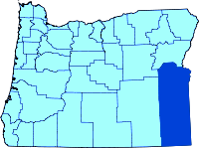

**Malheur**

**SWCD**

**July 08, 2015 – 8:00 am – 2:00 pm**

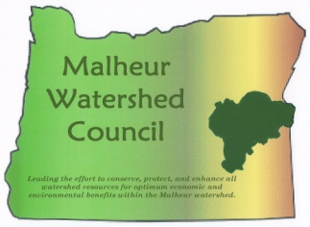**Presented by the OSU Malheur Experiment Station, The Ontario Chamber of Commerce, Ag Forum Committee, Malheur County SWCD, Owyhee**

**and Malheur Watershed Councils, Owyhee Irrigation District,**

**and OSU Malheur County Extension Service**



**Complimentary Lunch will be served.**

**Please reserve lunch by calling/email:**

* **Janet Jones, OSU Malheur Experiment Station at**

**(541) 889-2174/email** [janet.jones@oregonstate.edu](mailto:janet.jones@oregonstate.edu)



Owyhee

Irrigation District

* **John Breidenbach, Ontario Chamber of Commerce**

**(541) 889-8012/email** [ceo@ontariochamer.com](mailto:ceo@ontariochamer.com)

**OSUlogo4c**

Detach here

Please return Booth Application to

The Ontario Chamber 251 SW 9th St. Ontario OR 97914

##### Booth Application

**Cost: Free (*Note: Booth space only includes power and location space*)**

**Booth Size:**

**Power Requirements:**

**Special Materials: (handouts for youth) _____________________________________**

**Contact Name:**

**Organization:**

**Address:**

**Telephone:**

**Email:**

**Please provide door prize to be given away.**